**ACKNOWLEDGEMENT**

My initial thanks goes to the Industrial Tanning Division, University of Moratuwa, it’s director Mr. Ananda Gamage and the support stuff for arranging the industrial tanning programme which is a very valuable opportunity to engage and interact with the industry.

Also my heartiest gratitude does to Dr. (Mrs.) Dileeka Dias for being the initial coordinator for internship opportunity at the Singapore Management University. I also would like to thank the Electronic and Telecommunication Engineering department’s training coordinator Dr. Ruwan Udayanga Weerasuriya for guiding me at the most required moments during the training period. My sincere gratitude goes the department stuff, senior students and colleagues who though, guided and help me prior and during the training process to extract the best from the industrial training.

I would also like to extend my sincere gratitude to Associate Professor TAN Hwee Pink, Academic Director, SMU-TCS iCity Lab and Miss. Elina YU Jia, Assistant Director, SMU-TCS iCity Lab for selecting me as an intern at SMU-TCS iCity Lab. Also I am graceful to my supervisors Dr. Alvin VALERA, Research Fellow at SMU-TCS iCity Lab, Dr. TAN Hwee Xian, Research Scientist at SMU-TCS iCity Lab and Mr. Pius LEE Senior Research Engineer at SMU-TCS iCity Lab for guiding, mentoring and advising me though out the entire internship period. Also I would like to thank my fellow researches Miss. Xiao Ping TOH, Miss. TAN Lee Buay and Mrs. Cheryl KOH for the help and guidance given at the induction process. Finally I would like to thank Mr. Liming BAI and Mr. LA THANH Tam, Research Engineers at SMU-TCS iCity Lab for helping me with the technical aspects during the training.

I would like to thank the Singapore Management University staff for facilitating me though out the process. My sincere gratitude goes to the Singapore National Design Centre and iDA Lab staff for facilitating me with tools, equipment and fabrication facilities during the internship period.

Also my special thanks goes to Mr. Isuru Seneviratne for coordinating the accommodation facilities in Singapore.

**Chapter 1**

**Introduction to the Training Establishment**

**1.1 Singapore Management University**

Singapore Management University (SMU) is a world class university established in 2000 with the mission of generating leading-edge research with a global impact. Singapore Management University is well reputed for its state of the art small size class rooms and interactive, collaborative and project-based teaching approach. The university is a home for about 9300 undergraduate, postgraduate, executive and professional, full and part-time students. University is comprised of six schools in the areas of Accounting, Business, Economics, Information Systems, Law and Social Sciences.

Figure 1: SMU Logo

**1.2 TATA Consultancy Service**

****TATA Consultancy Service (TCS) is established as a division TATA Sons Limited in 1968. The company incorporated as a separate entity in the year of 1995 while being a part of the India’s largest conglomerate, the TATA group.

Figure 2: TATA Consultancy Services Logo

TATA Consultancy Services is an IT services and consultation company which provides business solutions to organizations and business entities. The Global Network Delivery Model™is one of the recognized industry bench mark developed by TCS in delivering IT services to its customers.

TATA Consultancy Services has more than 238,500 of the world’s best IT consultants over 45 countries. They handle more than 4500 IT contracts and have over 1500 more polled. The company operates over 13 European countries making it the Europeans #1 IT service provider in customer satisfaction. Currently the company has a combined value of 40 Trillion Euros making it one of the biggest IT service providers in the Europe Union.

**1.3 SMU-TCS iCity Lab**

**1.3.1 Brief History**

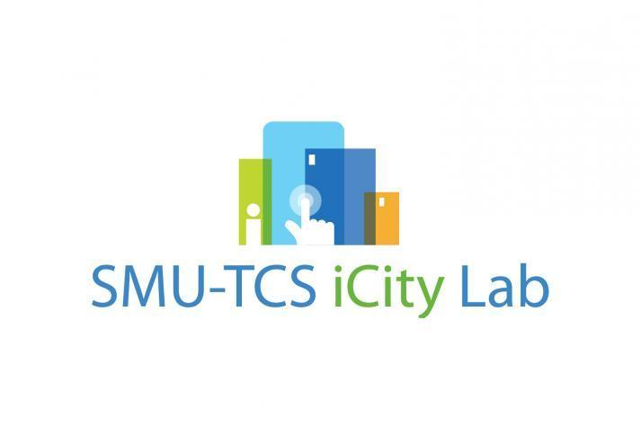SMU-TCS iCity Labs was initiated as a joint venture of TATA Consultancy Services and Singapore Management University. TATA Consultancy Services had invested S$ 6 million at iCity Lab for research in cloud based IT solutions.

Figure 3: SMU-TCS iCity Lab logo

The idea of a new research lab to build cloud based service platforms came in the play in the mid of the year 2011. Due to the heavy investment by TCS the inauguration of the lab came in the August same year. After doing a feasibility study and a survey the first project idea was started in the month of November and deployed in March 2012. One of the key ideologies came at the days of inauguration by the initiators was to take a people interaction approach for the research and development work rather than in-house development. This idea was one of the key reason for the success of the lab and the one of the key features which distinguish the iCity lab from the rest of the research labs in the field.

**1.3.2 Research forces and functional goals**

SMU-TCS iCity lab was initiating as a research laboratory which will help to flourish the Singapore Government’s vision of ‘Smart Nation’. The labs main forces was to develop intelligent systems and platforms for Smart City ideas. Labs research forces could be categorized into four main areas.

1. Aging
2. Healthcare and Chronic Disease
3. Education and life-long learning
4. Employability

**1.3.3 Projects and present performance**

Neighbourhood for Active Living (NodAL) was a pilot project done with the collaboration of Eastern Health Alliance (EHA) to setup a community based care management system for the Singapore East. The main forces of the system was to take care of the patients (mainly elderly) after discharging from the hospitals. The care intervention was done though regular phone calls and visits to the houses by the volunteer groups. One of the key goals of the project was to reduce the frequent hospitalization due to lack of after hospitalization care. This actually transformed the manual paper driven healthcare to a collaborative iCare system.

iCity Visual Analytics Toolset is another project developed by iCity labs that could be used to business and social data analytics. These tools could be used to analyse data forecast future predictions and trends in the field of businesses social behavioural patterns.

SHINESeniors is the current ongoing project of iCity lab which is a Remote Elder Care Platform. The operational perspective of the project is to collect sensor data from the PIR sensors and door sensors for the analysis of human behaviour.

In the currently deployment the lab had implemented four PIR sensors and detect the motion of the elderly with in the house. There is a door contact sensor to detect the outing of the elderly from the house. Also a medication box with a sensor is installed to collect medication adherence data of the elderly. 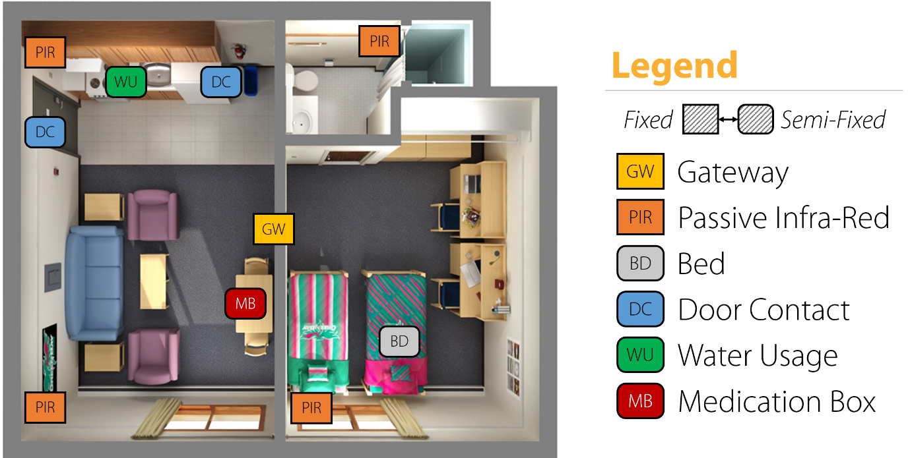The bed sensor detects the sleeping patters which could be used to detect anomalies in the normal sleeping patters. Besides the sensors a Panic Button was provided to elderly to alter any panic attacks.

Figure 4: Plan view of the sensor network in a one room flat

In the current modality a ‘No activity alert’ is triggered by analysing the PIR sensor data which is a suspicious call for the cases like elderly falling inside the house or fainting. Currently the distress alters are monitored by the iCity Lab staff and the Good Life, a volunteering association for elder care. In the future the operational power will be fully on the hand of the Good Life association.

Medication box is another interesting sub-project which is a part of the SHINESeniors project. The medication adherence data is quite useful for doctors in analysing the complications. Currently the elderly are alerted via a phone call if they miss any dosages. The lab is in the process of developing an automated process which could be monitored remotely by a care giver and make alters via a smart phone.

By the date the lab had complied 12 publications including two white papers. Due to the immense social impact the lab was able to secure a government grant of $ ……. For research and development.

**1.3.4 Organizational Structure**

Labs organizational structure is mainly into three main streams. They are Operations, Research and Development. Also the lab is monitored and by a two separate Steering Committee and an Advisory Committee.

Figure 5: SMU-TCS iCity Organizational Structure

**Steering Committee**

**Advisory Committee**

**Operations**

Senior Director

**Research**

Senior Research Fellow

**Development**

Chief Architect

Admin Officials

Student Interns

Research Scientists

Research Fellows

Research Interns

System Analyst

Developers

Interns

**1.3.5 Strengths and Opportunities**

Singapore government and health care associations are very much interested in the concept of ‘Ageing in Place’ which is a more sustainable solution for the growing population of elderly. Like most of the countries Singapore also faces the problem of imbalance population pyramid which will eventually lead to a huge elderly population in another 20-25 years. So the Singapore government had noticed this problem and currently promoting the ‘Ageing in Place’ concept. This is one of the main reasons that the iCity Lab started working on the SHINESeniors project as well. The government support is also one of the main strengths that the iCity Labs has. Also it is also a great opportunity for the lab to deploy a project like SHINESeniors.

TATA Consultancy Services is one of the biggest IT solution provider in the world. So in the initial dates the TATA consultation officers were helping the lab to start the projects and backing up the initialization process.

Besides TCS, iCity Lab is also collaborating with A-Star Research Company which the most reputed research institute in Singapore. With that collaboration, a considerable amount of knowledge, consultancy and help is flowing towards the lab. This is also a good strength that is available to the iCity Lab.

‘Lion Befrienders’ is another eldercare